**Yaml Audio Tool Rebuilt**

**V1.0.0 – 230424**

Table of Contents

Introduction 2

Overview 3

Main Program 3

Parameters 4

Playback 4

Organize 5

Room Creation 6

Destructive Effects Editor 7

Tools 7

Additional Tools 7

Example workflows 8

Create a Yaml file with audio content. 8

Edit audio files permanently. 8

Map a room to an audio file 9

# Introduction

The Yaml Audio Tool lets you organize audio files with different specifications to a Yaml list for further application (games etc.) usage. Within you can set various settings for later usage such as reverb, rooms, or technical specs. The playback engine is written under usage of XAudio2 to ensure equal “listening experiences” for games using XAudio2. Furthermore, the tool offers a small set of destructive audio editing tools. Supported files are:

* WAV files
* Sample rates from 22050 – 48000Hz (others might work but are untested)
* Bit Depth from 16 – 32 Bit
* Mono & Stereo files

Supported specs:

* Any multicore CPU (Intel or AMD) should work – ARM is not supported.
* Windows 8 & above (tested mostly on 10 & 11 64Bit)
* It’s not Crysis!

# Overview

## Main Program

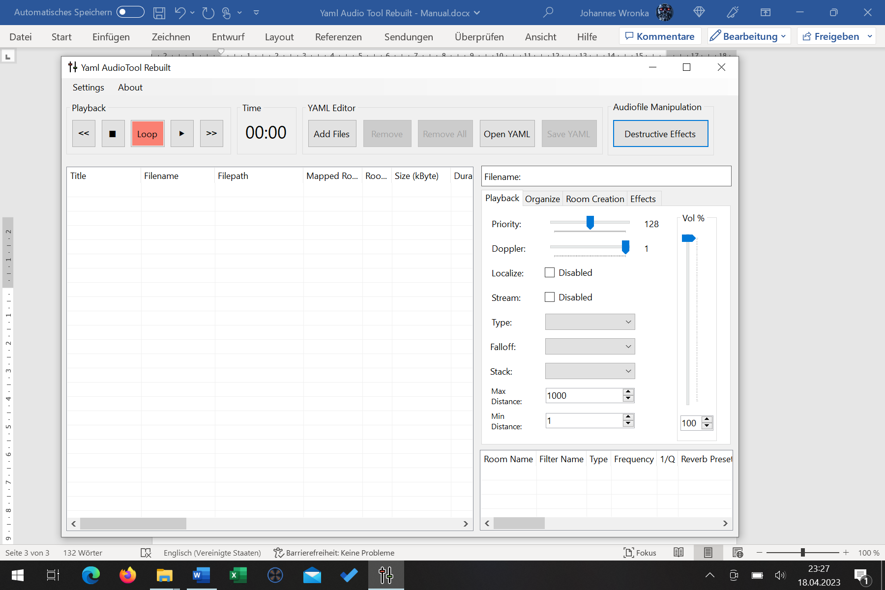

**9**

**8**

**7**

**6**

**5**

**4**

**3**

**2**

**1**

1. Settings & About section
2. Audiofile playback section
3. Playback time display
4. Audio-Yaml file Load & Save section
5. Destructive Effects audio file editor
6. Audio file list
7. Filename section
8. Parameters section
9. Room list

## Parameters

### Playback

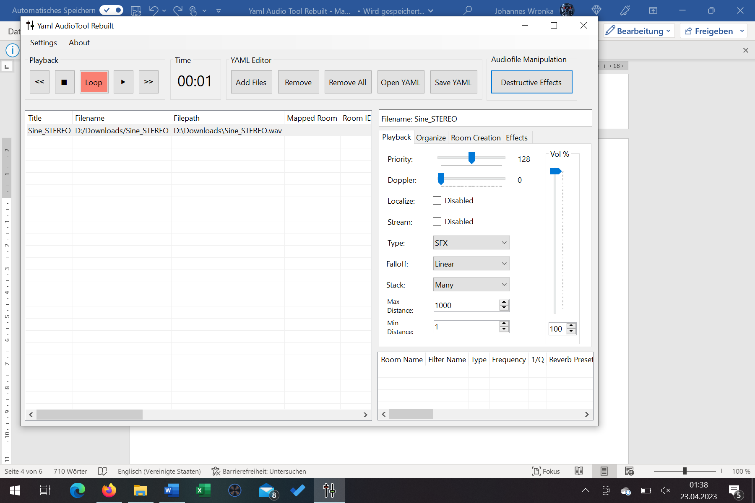

**Priority:** Determines the priority of the audio source amongst all the ones that coexist in the scene.

0 = most important

128 = Default

256 = least important

**Doppler:** Set the intensity of the audible doppler effect.

**Localize:** Automatically update the audio file when the locale has been changed.

**Stream:** This will mark the files to be put into RAM for faster access.

**Type:** Assigns the file to a specific group.

MUSIC

SFX

UI

Speech

Custom

**Falloff:** Determines the fade out of the file.

Linear

logarithmic

**Stack:** Determines how a sound playback is done in relation to its triggering.

Many = many instances can be created and overlap

Replace = the previous instance will be aborted

Drop = instance won’t be played back until the previous has been finished).

**Max Distance:** Determines the distance where the audio file isn’t audible anymore.

**Min Distance:** Sets the area where the audio file will be played back as loud as possible. Outside Min Distance the sound begins to attenuate.

**Vol:** Sets the volume of the audio file.

### Organize

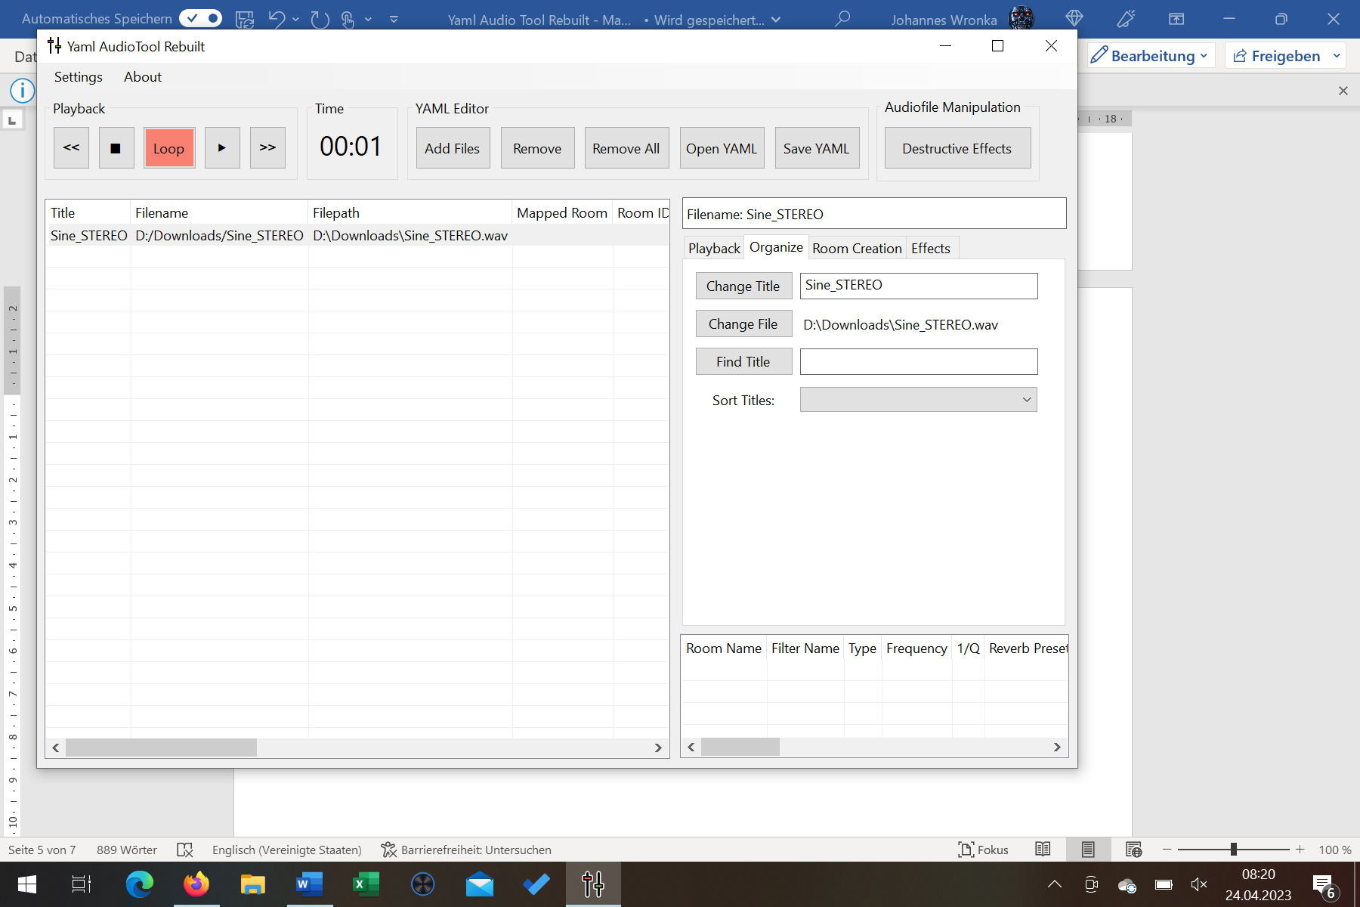

**Change Title:** Change the title of the file within the Yaml list (not the filename).

**Change File:** Change the file within the Yaml list.

**Find Title:** Find a specific file by searching for its title name.

**Sort Titles:** Sort all audio files within the Yaml list from specific parameters.

Title

Filename

Filepath

Room

Type

### Room Creation

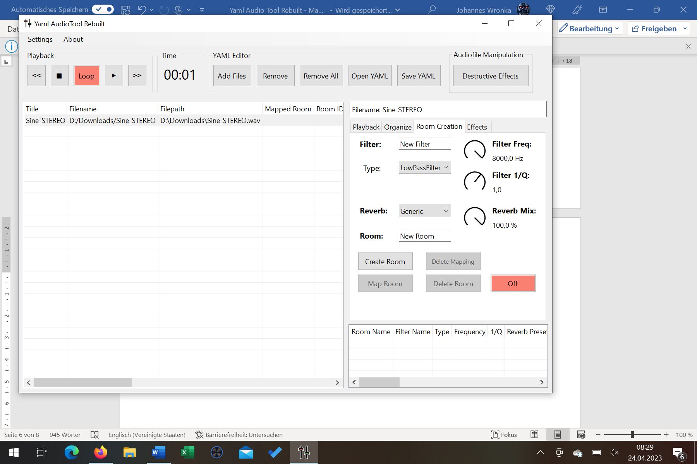

**Filter:** Set a new filter name.

**Filter Freq:** Set the frequency value where the filter should apply.

**Type:** Select a specific filter type.

LowPassFilter – All frequencies above the selected filter freq value will be damped by 1/Q.

BandPassFilter – All frequencies around the filter freq value will be damped by 1/Q.

HighPassFilter – All frequencies below the selected filter freq value will be damped by 1/Q.

NotchFilter – Creates a very small filter bell at the selected filter freq value.

LowPassOnePoleFilter – Frequencies above the selected filter freq value will be faded at -6dB.

HigPassOnePoleFilter – Frequencies below the selected filter freq value will be faded at -6dB.

**Filter 1/Q:** Sets the slope of the filter curve. The higher the value the higher the slope.

**Reverb:** Assigns one of the 30 available predefined reverb presets to the room.

**Reverb Mix:** Sets the percentual amount of the reverb effect to the audio playback.

**Room:** Set a new room name.

**Create Room:** Creates a new room setup with the specified filter and reverb settings in the room list.

**Map Room:** Links the room to the selected audio file in the Yaml list.

**Delete Mapping:** Removed the linkage between the room and audio file.

**Delete Room:** Removes the selected room from the room list.

**ON/OFF:** Sets the linked room on or off for the playback (only).

## Destructive Effects Editor

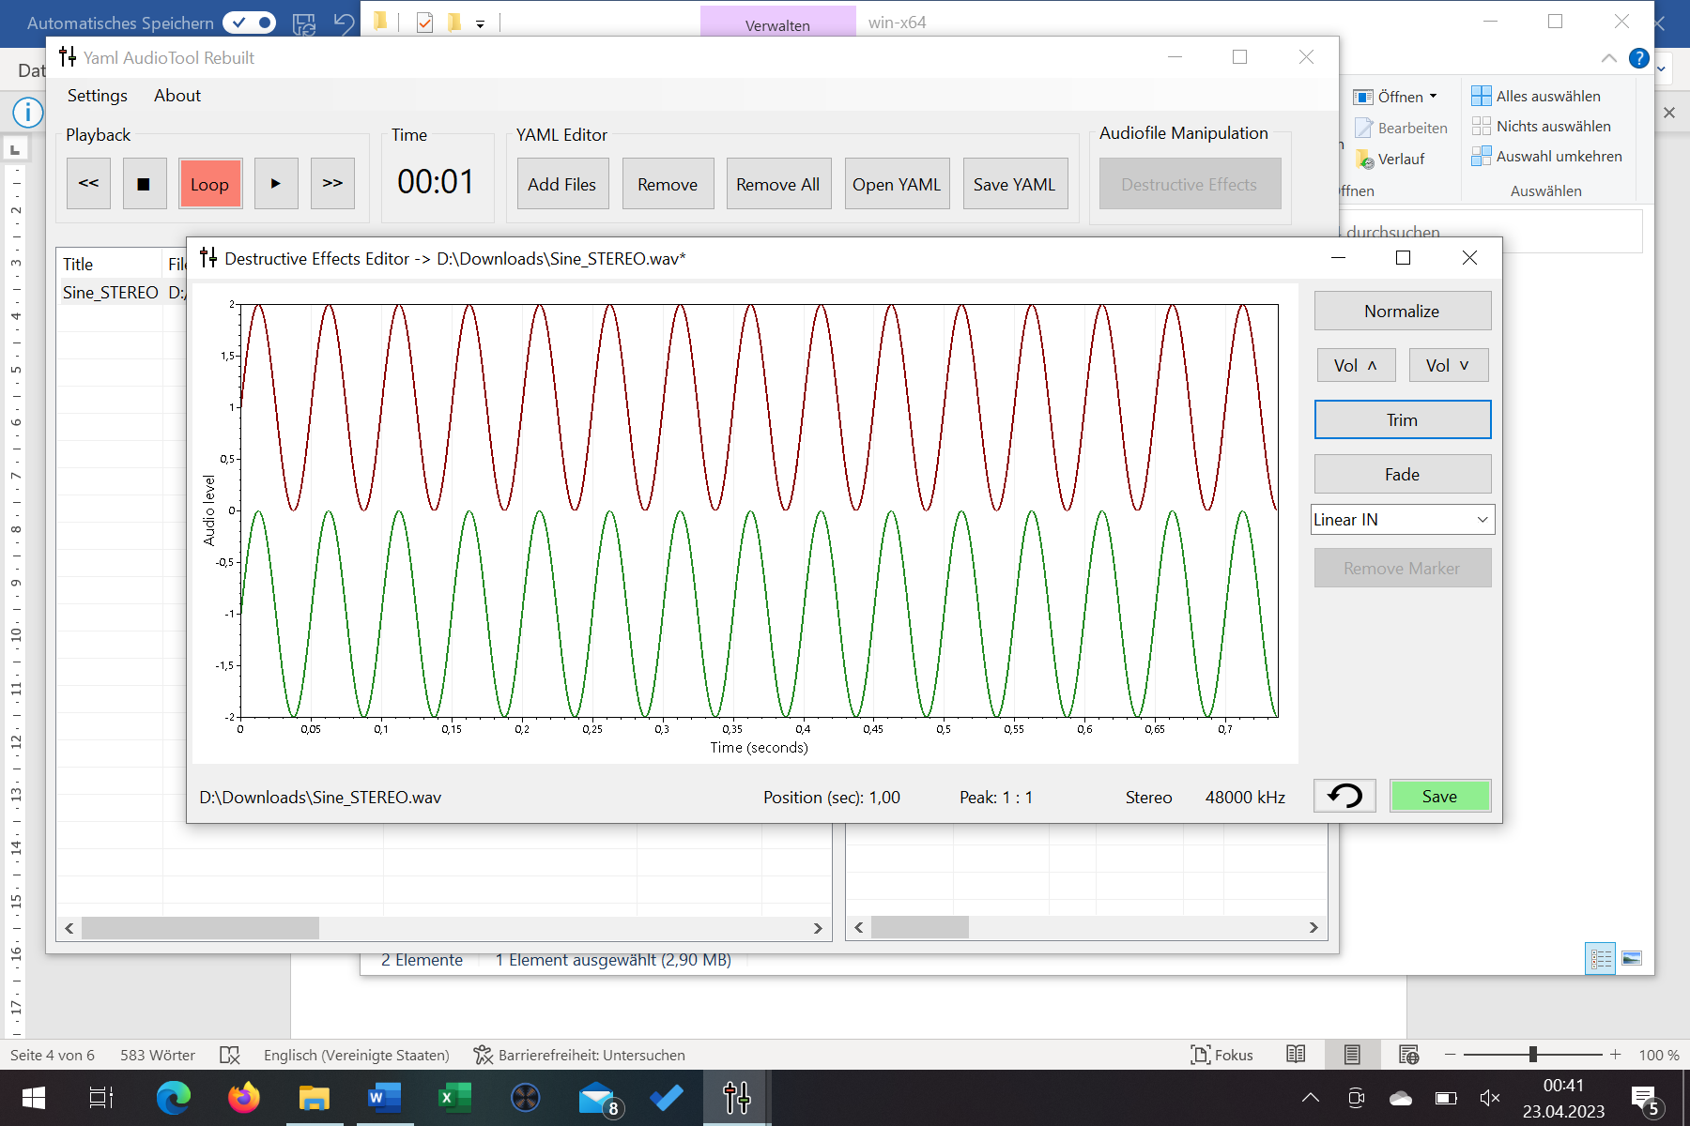

**4**

**3**

**2**

**1**

1. Audio file waveform window (displays mono + stereo)
2. Tools section
3. Audio file details (just visible with selected audio file)
4. Revert button (just visible after a first edit done) & Save button

Note: To make a selection within an audio file just click the left mouse button once at the start position and another time at the end position.

### Tools

**Normalize:** Set the volume to the maximum value depending on the maximum peak of the selected audio file range (or the entire file).

**Vol:** Turn the volume of the selected audio file up or down.

**Trim:** Cut out the selected part of the audio file.

**Fade:** Perform a Fade-In or Fade-Out (linear or expontial).

**Remove Marker:** Delete the markers within the selection of an audio file (if marker are available).

### Additional Tools

**Set Marker:** Select marker within an audio file by double clicking the left mouse button. You can set a maximum of 10.

# Example workflows

## Create a Yaml file with audio content.

1. Navigate to “settings” & define the folder that contains your audio data.
2. Load one or multiple audio files via “Add files”.
3. Click the file and set parameters from the parameters section as you wish. You might for example:
   1. Change the files volume.
   2. Set a specific reverb on it.
   3. Change its minimum or maximum distance.
4. Some setup parameters are audible during playback. You will for example hear added rooms with reverb or changed volume. Playback is possible over the playback section.
5. Create your Yaml file under usage of “Save YAML”.

NOTE: You can of course also load existent Yaml files and edit them further.

## Edit audio files permanently.

The Destructive Effects Editor is a simple (not more & less) tool to make small audio file corrections or modifications beside the Yaml parameters. These changes are permanently written into the wav file. Saved wav files are created as 32bit float files, independent from their original bit size. When saving your edited file, you have the possibility to back up your original file.

1. Navigate to “settings” & define the folder that contains your audio data.
2. Load one or multiple audio files via “Add files”.
3. Select the audio file you want to edit.
4. Open the audio editor while pressing the “Destructive Effects”-button.
5. Within the audio waveform window, you can now mark an area while pressing the left mouse button once and then move to the endpoint of your selection. Pressing the left mouse button again the selected area is fixed. Pressing the right mouse button will revert your selection.
6. Select a tool from the editors tools section for example the linear fade in.
7. The selected audio part will now be processed and can be either reverted (note this reverts all edit steps to the original file), overwritten or saved as new file.

## Map a room to an audio file

1. Load an audio file into the audio tool.
2. Navigate to the “Room Creation” tab.
3. Create a new filter:
   1. Set a filter name.
   2. Set a filter type with a specific filter frequency and slope (1/Q).
4. Choose a specific reverb preset for your room.
5. Create a new room:
   1. Set a room name.
   2. Create the room by clicking “Create Room”. The Room appears in the room list.
6. Select the room from the room list and the audio file from the audio file list. Click “Map Room” to link both the audio file together with the room. If you now save the audio file list to a Yaml file, the room link will also be stored.
7. To listen to your room setup, you can set the ON/OFF button to “ON”. If you playback the audio file now the linked room will be audible.